ALLIANCES AS A CAUSE OF WORLD WAR I

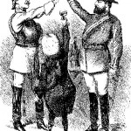
A representation of the Triple Alliance, with Italy as the junior partner
An alliance is a formal political, military or economic agreement between two or more nations. Military alliances usually contain promises of support between signatory nations, often in the event of war. The nature of this support is outlined in the alliance document. It can range from financial or logistic backing, like the supply of materials or weapons, to military mobilisation and a declaration of war. Alliances may also contain economic elements, such as trade agreements, investment or loans. Alliances are possibly the best known cause of World War I. During the 19th and early 20th centuries European nations regularly formed, annulled and restructured their alliances. By 1914 the Great Powers of Europe had shuffled themselves into two opposing alliance blocs. In theory, these alliance blocs meant that a war between two opposing nations might mean war between them all.

Alliances were not a new phenomenon in European history. For centuries Europe had been a melting pot of ethnic and territorial rivalries, political intrigues, competing ambitions, military threats, suspicions and paranoia. France and England were ancient antagonists whose rivalry erupted into open warfare several times between the 14th and early 19th centuries. Relations between the French and Germans were also troubled, while France and Russia also had their differences. European leaders relied on alliances as a defensive measure, a deterrent to war and a political device. The 1700s in particular was a century of shifting alliances. During this period kings and princes regularly formed or re-formed alliances, as a means of furthering their own interests and isolating rivals. Many of these alliances and alliance blocs were short lived. They collapsed when new leaders emerged or were overwritten by new alliances. In most cases these alliances were a strategic tool; alliances did not drag nations into an unwanted war.
The rise of French dictator and imperialist Napoleon Bonaparte in the early 1800s ushered in a brief period of ‘super alliances’. European nations allied themselves either to support Bonaparte or defeat him. Between 1797 and 1815 European leaders formed seven anti-Napoleon coalitions. At various times these coalitions included Britain, Russia, Holland, Austria, Prussia, Sweden, Spain and Portugal. Following Napoleon’s defeat at Waterloo in 1815, European leaders worked to restore normality and stability to the continent. The Congress of Vienna (1815) established an informal system of diplomacy, defined national boundaries and sought to prevent wars and revolutions. The congress system worked for a time but began to weaken in the mid 1800s. Imperial concerns, changes in government, a series of revolutions (1848) and rising nationalist movements in Germany, Italy and elsewhere saw European rivalries and tensions increase. Nations again turned to alliances to defend and advance their interests. Some of the individual agreements signed in the mid to late 1800s include:

The Treaty of London (1839). Though not an alliance, this multi-lateral treaty acknowledged the existence of Belgium as an independent and neutral state. Several of Europe’s great powers, including Great Britain and Prussia, were signatories to this treaty. Belgium had earned statehood in the 1830s after separating from southern Holland. The Treaty of London was still in effect in 1914, so when German troops invaded Belgium in August 1914, the British considered it a violation of the treaty.

The Three Emperors’ League (1873). This league was a three way alliance between the ruling monarchs of Germany, Austria-Hungary and Russia. The Three Emperors’ League was engineered and dominated by the Prussian statesman Otto von Bismarck, who saw it as a means of securing the balance of power in Europe. Disorder in the Balkans undermined Russia’s commitment to the league, which collapsed in 1878. The Three Emperors’ League, without Russia, formed the basis of the Triple Alliance.

The Dual Alliance (1879). This was a binding military alliance between Germany and Austria-Hungary, that required each signatory to support the other if one was attacked by Russia. It was signed after the collapse of the Three Emperors’ League and during a period of Austro-Russian tension in the Balkans. The alliance was welcomed by nationalists in Germany, who believed that German-speaking Austria should be absorbed into greater Germany.
The Triple Alliance (1882). This complex three way alliance between Germany, Austria-Hungary and Italy was driven by anti-French and anti-Russian sentiment. Each of the three signatories was committed to provide military support to the others, if one was attacked by two other powers – or if Germany and Italy were attacked by France. Italy, being newly formed and militarily weak, was viewed as a minor partner in this alliance.

The Franco-Russian Alliance (1894). This military alliance between France and Russia restored cordial relations between the two imperial powers. The Franco-Russian Alliance was in effect a response to the Triple Alliance, which had isolated France. The signing of the Franco-Russian Alliance was an unexpected development that thwarted German plans for mainland Europe and angered Berlin. It also provided economic benefits to both signatory nations, allowing Russia access to French loans and providing French capitalists with access to Russian mining, industry and raw materials.

The Entente Cordiale (1904). Meaning ‘friendly agreement’, the Entente Cordiale was a series of agreements between Britain and France. The Entente ended a century of hostility between the two cross-channel neighbours. It also resolved some colonial disagreements and other minor but lingering disputes. The Entente was not a military alliance; neither signatory was obliged to provide military support for the other. Nevertheless it was seen as the first step towards an Anglo-French military alliance.

The Anglo-Russian Entente (1907). This agreement between Britain and Russia eased tensions and restored good relations between the two nations. Britain and Russia had spent much of the 19th century as antagonists, going to war in the Crimea (1853-56) and later reaching the verge of war twice. The Anglo-Russian Entente resolved several points of disagreement, including the status of colonial possessions in the Middle East and Asia. It did not involve any military commitment or support.

The Triple Entente (1907). This treaty consolidated the Entente Cordiale and the Anglo-Russian Entente into a three way agreement between Britain, France and Russia. Again, it was not a military alliance – however the three Ententes of 1904-7 were important because they marked the end of British neutrality and isolationism.

Secrecy and hidden agendas
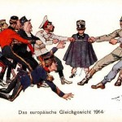
A depiction of the two alliance blocs, each pulling against the other
Most of these alliances and ententes were formulated behind closed doors and later revealed to the public. Some nations even conducted negotiations without informing their other alliance partners (Bismarck, for example, initiated alliance negotiations with Russia in 1887, without informing Germany’s major ally Austria-Hungary). Some alliances also contained ‘secret clauses’ not revealed to the public or placed on record; several secret clauses only became known after the end of World War I. The secretive nature of alliances only heightened suspicion and continental tensions. Further complicating matters were several small but significant alterations to alliance agreements, made by signatories in the years prior to 1914. A clause inserted into the Dual Alliance in 1910, for example, required Germany to directly intervene if Austro-Hungary was ever attacked by Russia. These modifications further militarised alliances and probably increased the likelihood of war. That said, the impact of the alliance system as a cause of war is often overstated. Alliances did not, as is often suggested, make war inevitable. The ultimate authority to mobilise forces or declare war still rested with national leaders. Their moral commitment to these military alliances was the telling factor. As historian Hew Strachan put it, the real problem was that by 1914, “nobody was prepared to fight wholeheartedly for peace as an end in itself.”

ALLIANCES AS A CAUSE OF WORLD WAR I

By 1914 the great powers had shuffled themselves into two opposing alliances. In theory, war between any two countries might mean war for them all.

The Treaty of London (1839)

Napoleon: anti Napoleon coalitions until early 1800’s (either for against him)
This treaty acknowledges the existence of Belgium as an independent and neutral state (it had once been part of southern Holland). This treaty was still in effect at the start of 1914, so Germany’s invasion was considered a violation.

The Three Emperor’s league (1873-1878)
Germany, Austria-Hungary, and Russia. Engineered by von Bismarck, who saw it as a means of securing the balance of power in Europe. It formed the basis of the Triple Alliance, with the nastiness in the Balkans (Russia relies now on Serbia, but Serbia is an enemy of Austria)

The Dual Alliance (1879)
An agreement between Germany and Austria-Hungary where they promise to protect each other if either is attacked by Russia. The Alliance was welcomed by many German nationalists, who believed that German-Speaking Austria should be absorbed into greater Germany.

The Triple Alliance of 1882
Germany, Austria-Hungary and Italy. Driven by anti-French and anti-Russian sentiment. Each committed to provide military support to the other two, OR if Germany or Italy were attacked by France. Italy was newly formed and considered militarily weak, and therefore seen as a minor partner in this alliance.

The Franco-Russian Alliance of 1884

In response to the Triple Alliance, this helps France feel secure. It angered Germany, who had imperialist notions regarding central Europe. It was also economically beneficial between France and Russia, allowing Russian access to French loans, and French industrialist access to Russian mining, industry, and raw materials.

The Entente Cordiale (1904)
A series of agreements between Britain and France. It was not a military alliance, but ended a century of hostility between the two neighbours. It resolved some colonial disagreements and other minor disputes.

The Anglo-Russian Entente of 1907
An agreement between Britain and Russia which eased tensions and restored good relations between the two nations. It included some resolution of colonial possessions in the Middle East and Asia. It did not involve any military commitment or support.

The Triple Entente of 1907
A consolidation of the Entente Cordiale and the Angle-Russian Entente. Not a military Alliance, but it, along with the other two Ententes, marked the end of British neutrality and isolationism.

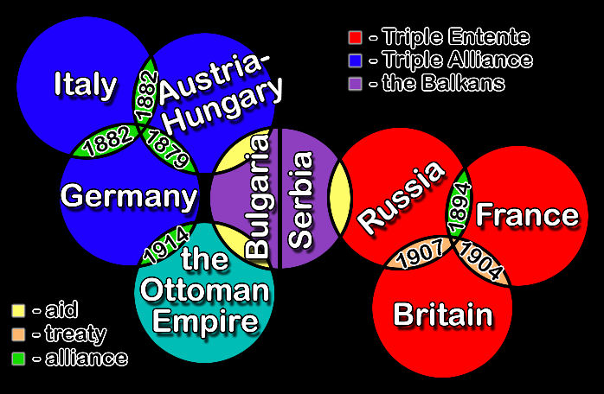

1. The alliance system was a network of treaties, agreements and ententes that were negotiated and signed prior to 1914.
2. National tensions and rivalries have made alliances a common feature of European politics, however the alliance system became particularly extensive in the late 1800s.
3. Many of these alliances were negotiated in secret or contained secret clauses, adding to the suspicion and tension that existed in pre-war Europe.
4. The Triple Alliance (Germany, Austria-Hungary and Italy) formed the basis of the Central Powers, the dominant alliance bloc in central Europe.
5. Britain, France and Russia overcame their historical conflicts and tensions to form a three way entente in the early 1900s.

